The Rabbits – Teachers Notes
http://www.thearrival.com.au/downloads/TG_TheRabbits.pdf

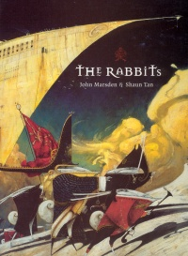 | The Rabbits.  John Marsden. Illustrated by Shaun Tan.  Vancouver, BC: Simply Read Books, 2003.  32 pp., cloth, $23.95.  ISBN 0-9688768-8-9.  Subject Headings:  Rabbits-Juvenile fiction.  Imperialism-Juvenile fiction.  Grades 2 and up / Ages 7 and up.  Review by Sylvia Pantaleo.  **** /4

The Rabbits is a compelling and disturbing allegory of colonization, industrialization and population growth. Many reviewers have used the word allegory to describe the book, but Shaun Tan, the illustrator, describes the book as a metaphor. Because Marsden is Australian, some have interpreted the story as the invasion of Australia by Europeans. However, the fundamental themes of the picture book are pertinent to humans throughout the world.

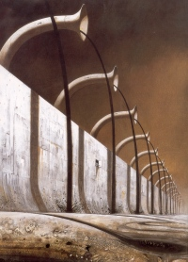
Text on the first verso reads, "The Rabbits came many grandparents ago." Initially, the inhabitants are tolerant of the newcomers, stating that, "At first we didn't know what to think. They looked a bit like us. There weren't many of them. Some were friendly." However, the elders' warning foreshadows the demise of the indigenous creatures and their land. As Rabbits continue to arrive in new and different ways, the original inhabitants begin to express concerns. A feeling of helplessness descends as the invaders take over and the illustrations communicate the imminent doom. On one double-page spread, Tan uses monochromatic colours to depict the conflict between the factions and the powerlessness of the native creatures. The collage-like appearance of this particular double-spread exacerbates the bleakness of the inhabitants' futures.
The Rabbits conquer the indigenous creatures. "We lost the fight." Tan juxtaposes the defeated native animals below the ground in bondage with the Rabbits above ground, their flags covering the land. The Rabbits continue to exploit the inhabitants and damage the environment. They commit the ultimate cruelty by stealing the children of the indigenous animals. An industrialized scene depicts the new status quo and the words "Might = Right" is inscribed at the bottom of a statute.
The Rabbits' legacy: destruction, desolation and despair. The book ends with the ultimate question, "Who will save us from the Rabbits?"
The text is minimal, yet the paucity of words is extremely effective. Tan uses colour and size symbolically in his stylized illustrations and the synergy between the text and illustrations is powerful. Many symbols are used throughout the text - the design on the Rabbits' flag, the clocks, and the arrows. The serenity of the end papers that depict waterfowl in a natural habitat are in stark contrast to the other illustrations in the book.
The Rabbits, first published in 1998, won the Australian Children's Book of the Year award in 1999. It also won the CBCA Picture Book of the Year Award. The Rabbits is an outstanding and sophisticated picture book that challenges and engages readers on multiple levels.
Highly Recommended.
Sylvia Pantaleo is an Associate Professor of Language Arts in the Faculty of Education at BC’s University of Victoria.

http://www.umanitoba.ca/outreach/cm/vol10/no19/therabbits.html

